hZáloha obrázků z projektu 1

max pro kibana down

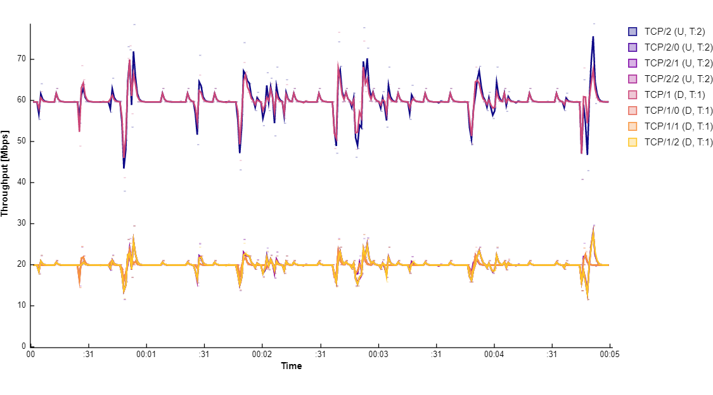

max pro kibana bezici - 100Mb testing

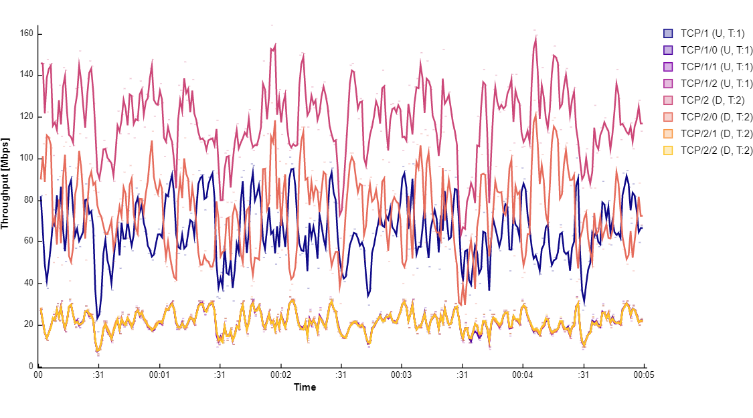

2/2tcp/2 upstream40.01082.664109.449297 [s]3.1 [GB]

1/1tcp/1 downstream38.93982.372109.094297 [s]3.1 [GB]

